*Used Oil Management Program*

User Guide

Version 0.0.1

Last modified on 14/09/2023 22:45:00

Number of pages 4

**Revision History**

|  |  |  |
| --- | --- | --- |
| **Date** | **Comments** | **Author(s)** |
| 2023-07-26 | Created the initial user guide. | Artyom |
| 2023-07-28 | Changed | Ani |
| 2023-09-14 | Changed | Ani |
|  | Approved 1.0.0 version |  |

**Table of Contents**

1. Introduction 3

2. Installation 3

3. User registration and login 3

4. Adding a Menu and Daily Orders 3

4.1. How to add a menu 3

4.2. How to place an order 3

5. Calculation of frequency and accumulation coefficient 4

6. Important Notes 4

* **Introduction**

Welcome to the Used Oil Management Program! This program is built to help restaurants manage their used oil by calculating the amount of generated oil. Below is a user guide to help you navigate through the functionalities of the program.

* **Installation**
* Download the source code or executable of the program.
* If you have the source code, compile it using a C++ compiler.
* **User Registration and Login**
* To register, provide an username, public food place name, secure password, address, email to create a profile.

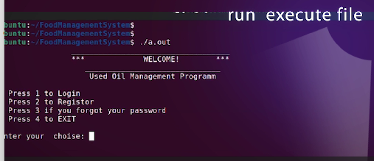

* To log in, enter your registered username and password.

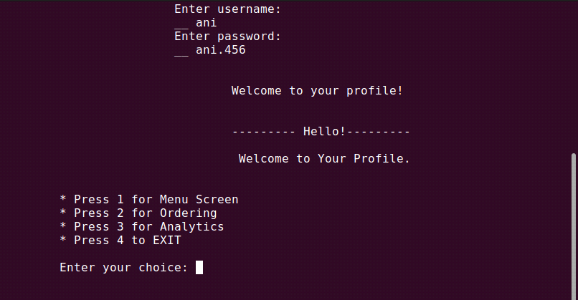

* If you forgot you password or username, enter number 4, allow the commands.
* **Adding a Menu and Daily Order**
* ***How to***

**Add a menu**

* After successful login, you can add your restaurant's menu to the program.
* The program will prompt you to input the menu items and their corresponding details (food name, amount of used oil for food).

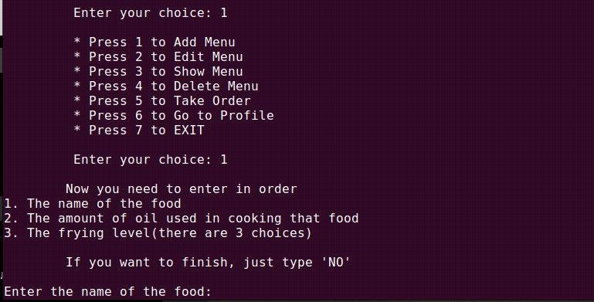

* Once you've finished adding the menu, the data will be stored in the program.
* ***How to***

**Place an order**

* To place an order, you will need to input menu items that customers have ordered from your menu.
* The program will then display the order summary.
* After confirmation, the order will be submitted to the program.

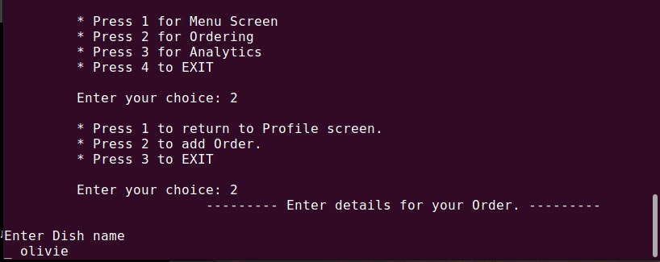

* **Calculation of frequency and accumulation coefficient**
* The program automatically calculates the amount, accumulation coefficient and frequency of used oil generated from each order based on the menu items that involve cooking oil.
* Calculations are added to your restaurant's profile.
* **Important notes**
* Make sure to keep your login credentials secure and do not share them with anyone.
* If you forget your password, select the "Forgot Password" option to recover your password.